# Recipes

You need to add 17 things to this document. (Make sure to number them just as I did in the example.) It may be helpful to copy and paste this list and then fill it in as you go along. All image names must start with your location, e.g yellowstone_sunset.jpg unless you are using a link from the internet.

## Coca-Cola Chicken Wings

1. **Origin**: China
2. **Source**: Family Recipe
3. **Category**: Main Dish
4. 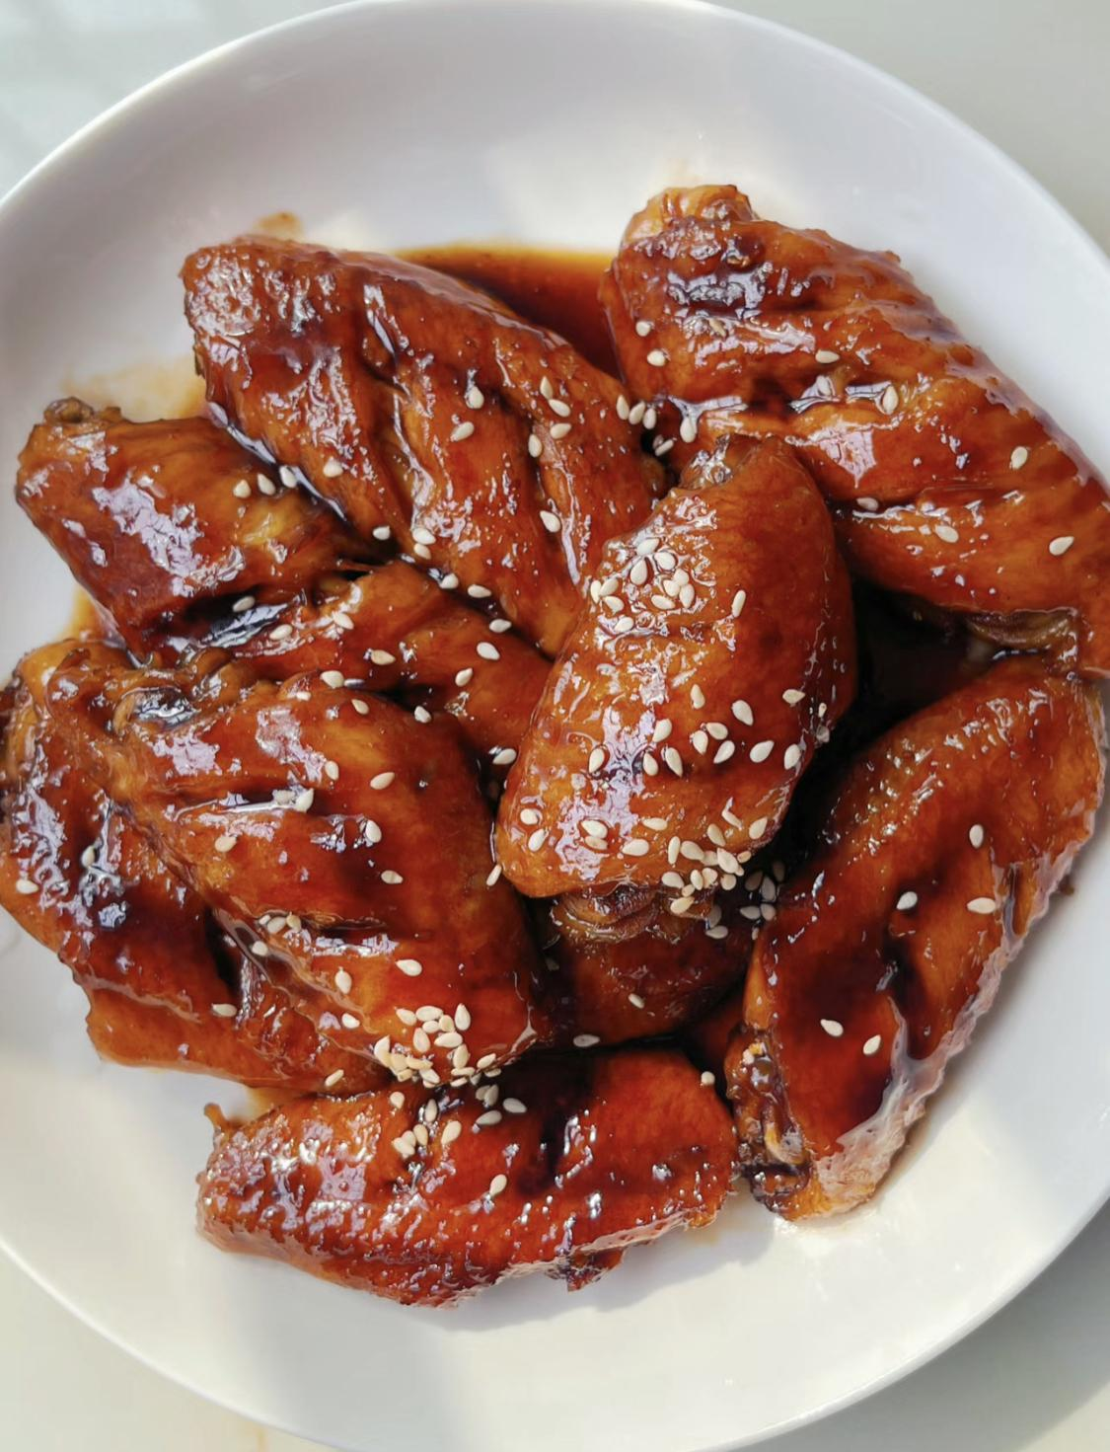
5. coca_cola_chicken_wings.jpg
6. I learnt how to cook Coca-Cola chicken wings from my mother, and I've since tweaked her recipe to better suit my family's palate, making it less sweet. While the cooking process remains straightforward, the result is incredibly flavorful, and once you've tried it, you'll understand its delicious appeal!
7. **Recipe Ingredients – Just write Recipe Ingredients**
   1. Chicken wings
   2. Scallions
   3. Ginger slices
   4. Cooking wine
   5. Dark soy sauce
   6. A can of coke
8. **Recipe Steps – Just write Recipe Steps**
   1. Wash and place chicken wings in a bowl
   2. Add scallions, ginger slices, cooking wine, dark soy sauce and salt to the washed chicken wings, and mix them well
   3. Cover the bowl with plastic wrap and marinate the chicken wings for 1 hour
   4. Put the right amount of oil in the pot, and put the marinated chicken wings into the pot and fry it until golden brown on both sides
   5. After fry the chicken wings until golden brown on both sides, then pour a can of coke into the pan and bring to a boil
   6. Continue to cook for an additional 2-3 minutes until the glaze has thickened and coats the wings nicely
   7. Transfer the Coca-Cola glazed chicken wings to a serving platter
9. **Additional Food images**

For the next three pictures you can just put the names of the files, you don't have to include the files in this drive, but you do need to add them to the proper Google Drive.

1. chicken_wings_chopsticks.jpg
2. A chicken wing picked up by chopsticks
3. boils_in_coke.jpg
4. Chicken wings boiled in coke
5. chicken-wings_and_rice_cake.jpg
6. Coca-cola chicken wings served with rice cake
7. Sisi Chen